[**Back to HCI Lab Home Page**](http://iitg.vlab.co.in/?sub=72&brch=170)

**What is short-term memory?**

**Short-term memory** **(STM)** is  the capability of  holding information in mind in active, readily available state for a short period of time. The duration of short-term memory is in the order of seconds.

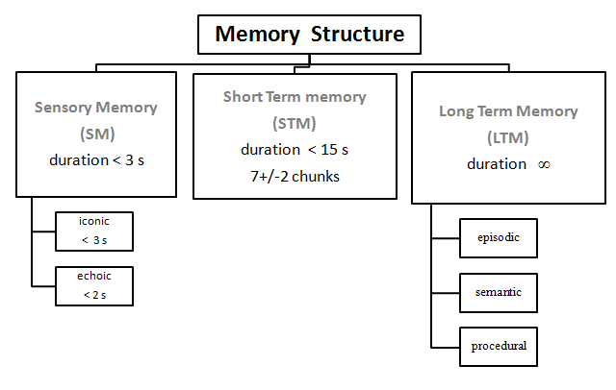

**Duration of short-term memory**

The contents in STM spontaneously decay over time. Thus to retain information for longer time, the information must be periodically repeated or rehearsed.

**Capacity of  Short Term Memory**

Experiments have shown  that STM  has  a  limited  capacity to remember  7+/-2  chunks of information at  a time. This limit is called memory span. In a memory span test, the experimenter presents lists of items (e.g. digits or words) of increasing length. An individual span is determined as the longest list length that he or she can recall in the given order  for at least half of  the times.

**Chunking**

Chunking is a process by which you  can expand your ability to remember things in STM. Chunking means organizing information into meaningful groups. Average person can retain only about four different chunks(units) in short-term memory  at  a  time. Effective chunking can greatly increase a persons recall capacity. For example, in recalling a phone number, the person could chunk the digits into three groups: first, the area code (such as 215), then a three-digit chunk (123) and lastly a four-digit chunk (4567). This method of remembering phone numbers is far more effective than attempting to remember a string of 10 digits.

(Source :  http://en.wikipedia.org/wiki/Short-term_memory)

In an experiment it was observed that out of 10 letters presented a person could recall 7 letters easily. Similarly out of 10 words presented a person could recall 7 words. This is because the words were stored in STM in chunks of letters and not individual letters. Thus regardless of the content, chunking improves the amount of information recalled. Miller offered an explanation to how items are coded in STM  using chunking theory.

  To proceed  further  click on the **OBJECTIVE** tab on the top or to exit this experiment  click on **HOME**  on the top.

[**Back to HCI Lab Home Page**](http://iitg.vlab.co.in/?sub=72&brch=170)

Incoming information is encoded as chunks in STM by referencing LTM. Mostly STM operates by auditory coding of input stimuli. We hold information in STM by auditory rehearsal.

**After performing this experiment**

1.  You will  find evidence of information being stored in STM by means of  **visual** **coding of input stimuli.**

   (Posner  and  his  associates [Posner,1969] found  that , at least  part  of  the  time ,  information  is coded visuallyin STM.)

 To proceed  further  click on the **PROCEDURE** tab on the top or to exit this experiment  click on **HOME**  on the top.

[**Back to HCI Lab Home Page**](http://iitg.vlab.co.in/?sub=72&brch=170)

1.    In the first part of the experiment you will be shown two alphabets side by side (see the figure below). You will be asked to indicate by pressing a button whether the two alphabets are  **Same or Different.** Your reaction time for pressing the button will be recorded.

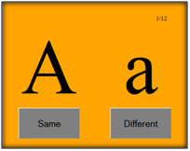

Following table shows the correct responses

|  |  |  |
| --- | --- | --- |
| **Condition** | **Examples** | **Correct Response** |
| Visual  and  name  match | A  A | Same |
| Name  match | A a | Same |
| Visual  and  name  mismatch | A  T | Different |
| Visual  and  name  mismatch | A  t | Different |

**Observations to be noted**

You will observe that the reaction time for the second condition ( A a  )  will  be  more than for the first ( A A ). This is because identical letters (A A) are judged by their visual characteristics while letters having the same name but  different shape (A a ) are compared by their verbal characteristics. Thus  the  A A  match  was  made  on  the  basis of physical (visual code)  and  so  the  response  time  is  less. Thus  coding of information in STM is first visual and then based on name.

In case  when alphabets are  shown  after  a  time  delay  of  few  seconds   the  name   coding  takes  over  the  visual   coding   and  hence  the  difference  in  response  time  for  A A  and   A a  is  very  less.

**The experiment has three sub parts. All of them can be tried out.**

(a)       Character Set

(b)       Color Set

(c)       Image Set

**Please  follow  following  procedure**

1.     Click on the SIMULATOR tab to proceed for the experiment.

2.     You will see a button which will direct you to the experiment page.

3.     Read  instructions given carefully  for each experiment and perform all 3 parts in sequence.

4.     A graph will be displayed after each sub-experiment. You  are  expected to capture this graph and save it on to your local drive.

5.     Try to analyze the graphs and see if  the results about STM prove to be valid in your case.

To proceed  further  click on the **SIMULATOR** tab on the top or to exit this experiment  click on **HOME**  on the top.

[**Back to HCI Lab Home Page**](http://iitg.vlab.co.in/?sub=72&brch=170)

To go to experiment page  :  [http://iitg.vlab.co.in/userfiles/7/image/uelabs/dwnld.png](http://125.20.82.167/uelabs/exp13/newexp/index.php)

 To proceed  further  click on the **QUIZ** tab on the top or to exit this experiment  click on **HOME** on the top.

[**Back to HCI Lab Home Page**](http://iitg.vlab.co.in/?sub=72&brch=170)

1.     What long does any information remains in Short Term Memory?

2.     What is the memory span of STM for an average individual?

3.     How will you increase the memory span of  your STM?

4.  In which different ways is information coded STM?

5.     What hypothesis has  been  validated  in these  experiments?

 To proceed  further  click on the **ASSIGNMENT** tab on the top or to exit this experiment  click on **HOME** on the top.

[**Back to HCI Lab Home Page**](http://iitg.vlab.co.in/?sub=72&brch=170)

 1.  Device 3 experiments to prove existence of iconic, echoic and haptic sensory store? You  can search  the web.

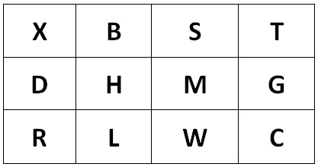

2. Refer to the above matrix of alphabets. Show this matrix to a set of respondents for around 10 seconds only.

   Then ask them to recall and draw the same matrix on a paper.

    Now for another set of respondents do not show them the matrix. Instead read the letters to them row-wise in

    HIGH, MID and LOW tone respectively for row1, row2, row3.

     Find out the average percentage and number of (a) characters recognized (b) locations recognized for  the both set of respondents.

     Analyze your results. Can you infer anything from this?

 To proceed  further  click on the **REFERENCE** tab on the top or to exit this experiment  click on **HOME** on the top.

[**Back to HCI Lab Home Page**](http://iitg.vlab.co.in/?sub=72&brch=170)

**Books:**

**                                              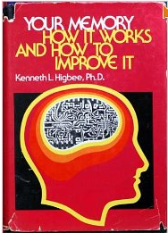**

**URLs**

( as on 26 January 2012 )

**10 Fascinating Feats of Human Memory**

http://thelistcafe.com/10-fascinating-feats-of-human-memory

**The Human Memory**

http://www.human-memory.net/

**Sensory Store in Short Term Memory**

http://www.cindy.sifonis.com/Classes/Cog316/cogline/sensory%20store%20and%20STM.pdf

**Short-Term Memory and Web Usability**

http://www.useit.com/alertbox/short-term-memory.html

   To give feedback  for this experiment click on the **FEEDBACK** tab on the top or to exit this experiment click on **HOME**  on the top.